Welfare Accessible Manifestos

Shivanii Arun
Shiv for Welfare
and Kieran
Hi! I'm Shivanii (she/her), a first-year studying Law with Law Studies in Europe. I'm running with Kieran DeWalt to be your Welfare reps for 2022-2023!

Our Ideas (Check out Kieran's manifesto for even more!)
Better peer support network
There are so many peer supporters on hand to help, but they're just not visible enough to the JCR. We propose assigning peer supporters to fresher households - a chance for us to manage and check in on small groups, and for freshers to get to know us better.
Sex-ed talks for Freshers
Sex-ed varies with school, background, and country. We want to source help for incoming freshers to learn more about how to have safe sex. We're keen to work with Imogen in their role as LGBTQIA+ rep to work on improving understanding of LGBTQIA+ sex education.
More (intersectional) college family events
College families can be a great source of both academic and welfare support. While subject families have plenty of opportunities to get to know one another at subject dinners and events (which we want to continue and increase!), this isn't the case for international and rainbow families. This is something we'd like to work on as part of our agenda for a better peer support network.
Welfare week care packages
Everyone loves welfare week! But even with so many events on, we understand that it can be difficult to actually make it to things. So, we'd like to bring welfare to you with customisable care packages available to pidge for anyone who you feel could benefit from a little W5 welfare (including yourself).
Kieran: “wow Shiv look at that diverse array of excellent suggestions we've come up with”

Why Me?
Since 2019, I've been a lead volunteer and welfare contact at a community youth summer camp in Birmingham, welcoming up to 200 children aged 8-18 each year. I also have experience running a mental health awareness Instagram page (@sincerely.talk) and organising a broader Time to Change mental health campaign for Mind charity in secondary school. Filling George and Jana's shoes is a daunting task. Aside from continuing their amazing work, I'm very passionate about increasing the intersectionality of welfare at Merton. Whatever the source of your worries, it's important to me to navigate them with you through the best channels possible. Nobody should feel like welfare doesn't cater to their needs.
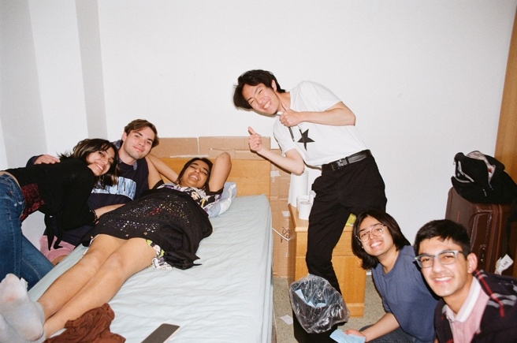
Caption: experienced welfare-receiver
Here for you
At the end of the day, as welfare reps, the most important job of all is to be there for all of you; whether that's for you to vent, seek advice, be distracted, or just have somebody to keep you company for a little while. I love our college community, and I want to keep it a safe place where people feel comfortable and able to share their emotions whenever they need. Kieran and I promise to always fight in your corner.
@shiversarun

Benjamin Atkinson
BENJAMIN FOR WELFARE
WHO AM I?
I am a Classics fresher with a lot of time to give to others, a love of punting, and an aptitude for climbing *coughs awkwardly*. I believe I am a caring person and a considerate listener, and hope that enough of you will think the same to vote on that basis. Pronouns he/him.
MY INDIVIDUAL GOALS AND INTERESTS
Tea - many will know me for a great tea lover. I intend to continue our marvellous tradition of welfare teas, and reinstate our former variety of flavours. Eleanor has some delusions of grandeur in this field.
Gardens - I believe appreciating gardens will really help people’s welfare so I’ll organise garden events and try to arrange activities with the gardeners.
Punting - nothing is more relaxing than a good punting trip! I want to offer this especially to freshers next year.
Music - I have my own tastes, but I believe the therapeutic power of music is universal and I want to put that to use.
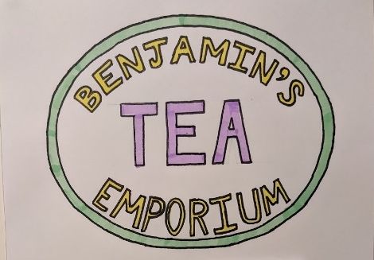
BENJAMIN AND ELEANOR
Welfare officers must trust each other absolutely, and if you know us, you’ll know that we do have complete faith in each other to share our duties fairly, and to act independently if necessary on any confidential issues. Most importantly, while we have our own individual spheres and interests, our aims and visions for college welfare are united. We view this unity as our greatest strength.
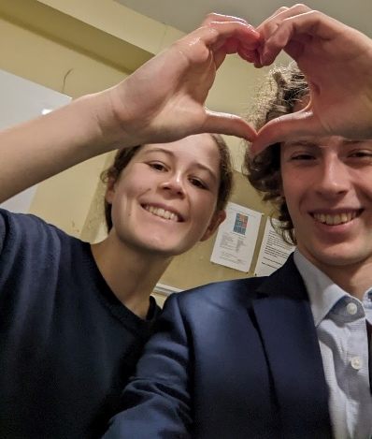
POLICIES
For us, welfare is so much more than bopping and mopping (a job which we will nevertheless take on with gusto). We think it involves the following:
Proactivity - We don’t believe in sitting back and waiting for you to ask for help. We’ll always be sensitive to whether help is wanted. However, we will always be actively watching for things. We can’t promise to notice everything, but we can promise to be always looking out.
Advocacy - We know it’s difficult to stand up for yourself alone. We will always listen to you impartially and indiscriminately. Then we will act quickly and confidentially to meet or communicate your needs as necessary.
Time - Everyone can feel quite short on time in Oxford, but we will always be there to give ours to you. Knowing how to deal with life’s many trials can be difficult. However, we believe in the simple power of being confident that someone will take the time to hear you out.
(Eleanor can punt too.)
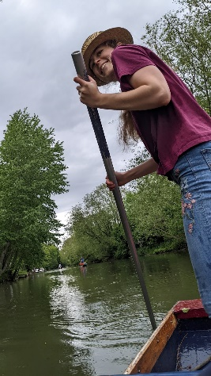

Eleanor Clark
ELEANOR FOR WELFARE

WHO AM I?
I’m an English fresher who tries her best but wants to try harder to get out of the library. Merton is a wonderful place and I’m forever feeling lucky to be here - but the ‘best years of your life’ might also be some of the hardest, and I want to be here to help you through. Pronouns she/her.
MY INDIVIDUAL GOALS AND INTERESTS
Tea - Let’s be honest, I make a better cuppa than Benjamin, actually, and he knows that. (I may advocate for something stronger than Tetley.) Also, I drink coffee too, and will stand up for your coffee rights.
Walking - I go for a walk daily whatever the weather and it’s the best antidote to stress I know. I hope that might be the same for you and I will always be happy to walk and talk. Crafty things - Jana’s craft nights are a brilliant idea and I’d love to continue holding regular events where people can bring their own practical projects. Pets - we’ll all have a GB-shaped space in our hearts, so I’d look to arrange some animal related welfare activities. I’ve got 3 cats and once owned a tropical frog, so I promise to be inclusive!
Baking - I’m not exactly Mary Berry, but I do try. Legend has it that my crumbles are pretty good. (I think Benjamin’s words were “better than the Ambrosia of Olympus” or some such.)
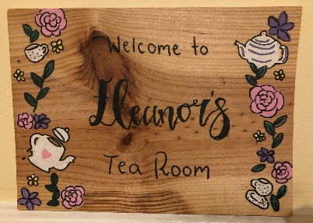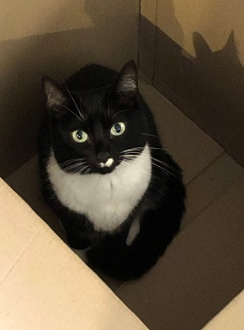
BENJAMIN AND ELEANOR
Welfare officers must trust each other absolutely, and if you know us, you’ll know that we do have complete faith in each other to share our duties fairly, and to act independently if necessary on any confidential issues. Most importantly, while we have our own individual spheres and interests, our aims and visions for college welfare are united. We view this unity as our greatest strength.
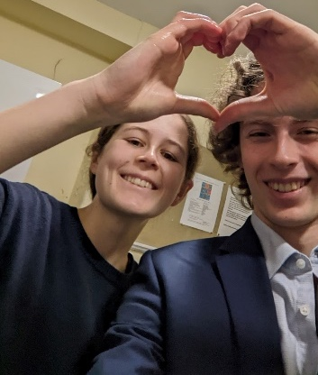
POLICIES
For us, welfare is so much more than bopping and mopping (a job which we will nevertheless take on with gusto). We think it involves the following:
Proactivity - We don’t believe in sitting back and waiting for you to ask for help. We’ll always be sensitive to whether help is wanted. However, we will always be actively watching for things. We can’t promise to notice everything, but we can promise to be always looking out.
Advocacy - We know it’s difficult to stand up for yourself alone. We will always listen to you impartially and indiscriminately. Then we will act quickly and confidentially to meet or communicate your needs as necessary.
Time - Everyone can feel quite short on time in Oxford, but we will always be there to give ours to you. Knowing how to deal with life’s many trials can be difficult. However, we believe in the simple power of being confident that someone will take the time to hear you out.
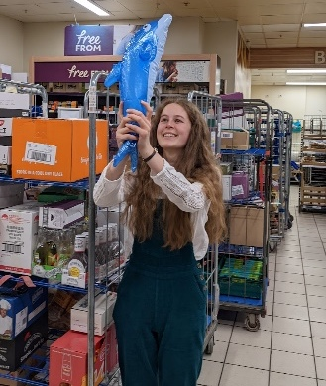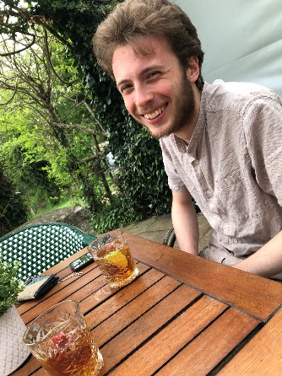

Kieran Dewalt
Kieran For Welfare
and Shiv 😊
Hi everyone! I'm Kieran (he/him), from Chapel Hill, NC in the United States. I am a first-year studying maths and philosophy, and I am running with Shivanii Arun to be your Welfare reps next year!
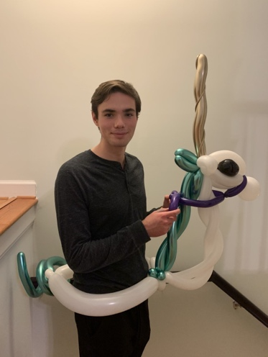
Caption: Ask me about balloon animals (it's welfare related)
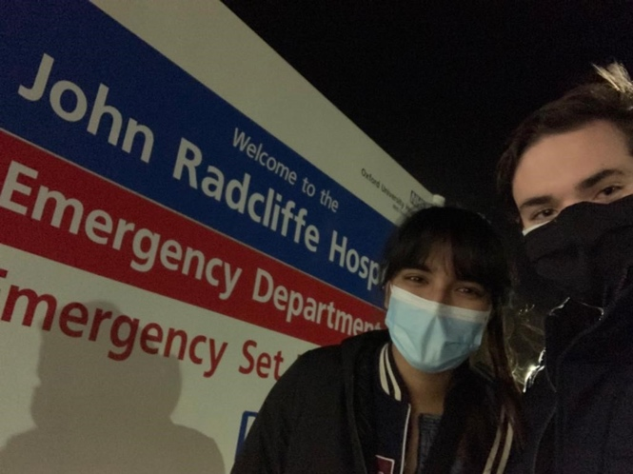
The JCR needs welfare officers who are reliable and approachable to all members -- Shiv and I fit the bill.

Why Me?
I arrived in England in the fall knowing zero people here, so I understand how essential a support network is to university life. I would be excited to give my time to make sure that everyone at Merton, no matter your background, knows that the JCR will support you though any issues you may face. As a swim coach for my neighbourhood team for 4 years I learned many support and conflict mediation skills. I am also experienced helping family and friends through mental health issues.
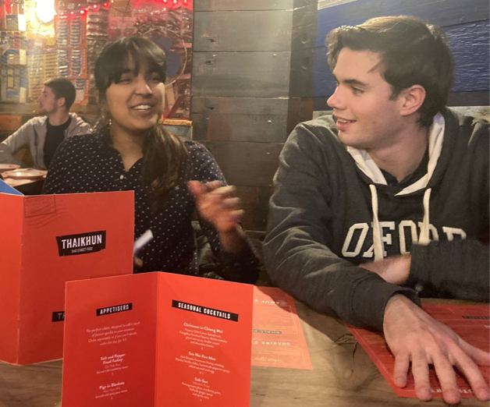
Our Team
Shiv and I have been friends since the start of Michaelmas, and have (somehow) stayed friends ever since. Running Neave society as President and Treasurer over the past two terms has given us an idea of each other’s strengths and weaknesses, and we’re really excited to do it again! We’re confident we’ll make a great team - and great welfare reps for you.

Our Ideas (Check out Shiv's manifesto for even more!)
Welfare Information
At the beginning of the year, Freshers are overloaded with important information. We would update the already wonderful Welfare Guide and emphasize the resources the College and university has to offer. Then, make sure every fresher has a physical copy, along with posting reminders of essential details throughout the year through Instagram, Facebook, and physical posters.
Academic/Welfare Communication
Your physical/mental health issues should not be separate from academic support. We want to make the process of receiving academic support automatic when you reach out to us or the college for welfare support, so the onus is no longer on you to sort things out alone. Increasing awareness of what college support is already available for physical and mental disabilities is also a key priority for us.
Safety in University
To thrive in university it is absolutely necessary to feel physically safe, yet the reality is that attacks and abuse occur. We would continue educating undergraduates on prevention and emergency plans through Freshers week, the Welfare Guide, and social media, and would also continue to distribute personal alarms. In addition, we want to actively connect JCR members with existing university self-defence and first-aid societies by accompanying them and partially subsidising costs, i.e. covering the cost for one workshop.
Event promotion and feedback
Welfare reps host a plethora of lovely events every term, in addition to Welfare tea and Welfare week, which are an important way to connect with the college community! To make sure everyone is aware, we would use Instagram and Facebook to promote each event. In addition, Shiv and I are committed to actively seeking feedback on the events the JCR wants to see happen through conversations and social media (and not just a google form).
@kierandewalt

